Building GUIs

An introduction

GUI principles
Components: GUI building blocks.
- Buttons, menus, sliders, etc.
Layout: arranging components to form a usable GUI.
- Using layout managers.
Events: reacting to user input.
- Button presses, menu selections, etc.
Styling: making things look nice
- In code vs. Using CSS
Animation and effects
- Building modern interfaces

AWT, Swing and javafx
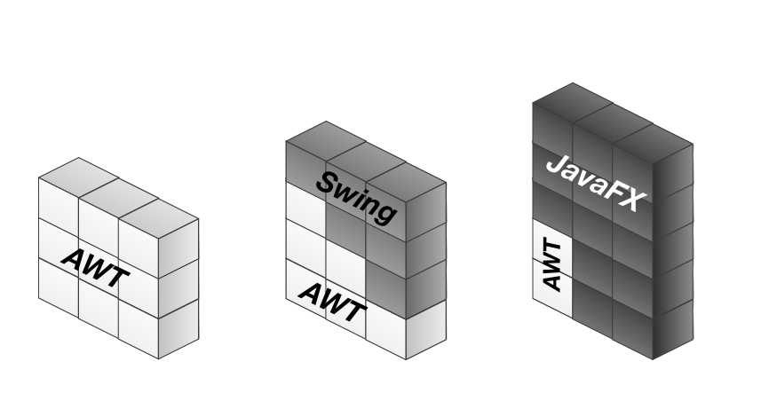

Java fx
We will use Java FX
- Included with Java SE since JDK 7
- Currently not included in the standard Java download, but available separately
  - BlueJ includes JavaFX
- Used in code via import javafx.*

Structure

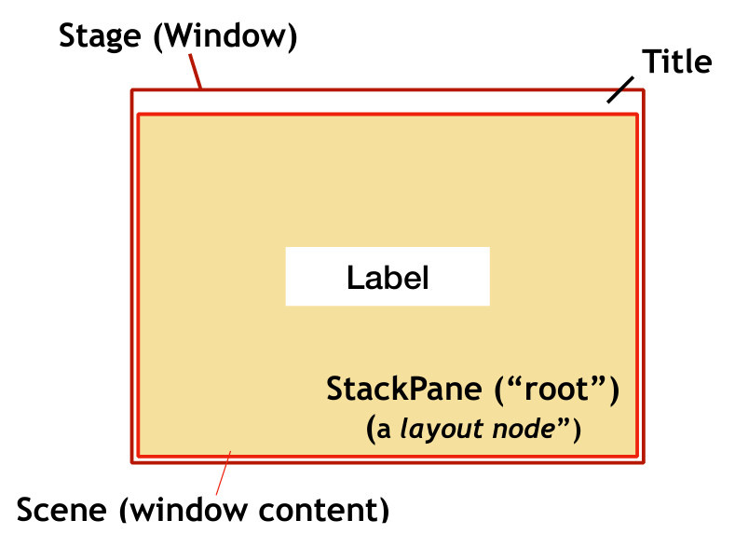
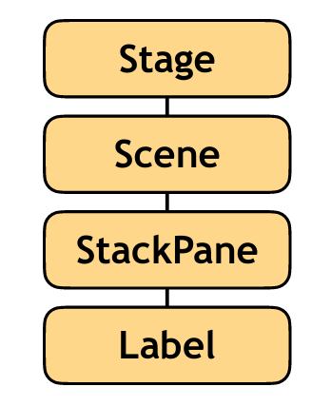

Controls
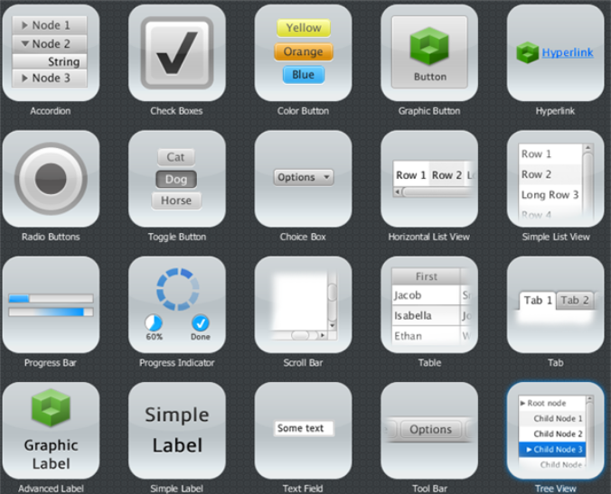
https://docs.oracle.com/javafx/2/ui_controls/jfxpub-ui_controls.htm

Layout
JavaFX has different Layout Panes:
- BorderPane
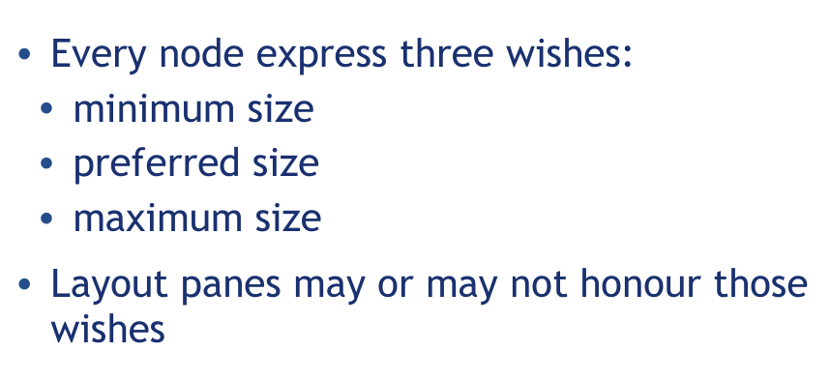
- HBox
- Vbox
- StackPane
- GridPane
- FlowPane
- TilePane
- AnchorPane
(See appendix for explanation of all layout panes)

Varargs
- All ‘parent’ nodes have children
- Held as an internal list
- Pane exposes children:
ObservableList<Node> getChildren()
- Child nodes added by adding to this list:
root.getChildren().add(button);
You have two options for Varargs:
root.getChildren().add(button);
root.getChildren().addAll(button1, button2, …);
How do these work?

Writing varargs
public void sample(int… values)
{
for (int n: values) {
[…]
}
}

public void sample(int… values)
public void sample (int n, String… words)
sample(4, “one”);
sample(4, “one”, “two,” “three”);

- Only one vararg parameter in each method.
- Vararg parameter bust be last in signature.

Appendix: All layout managers
